POLICYPORTAL2020

SuperMentor

1. Creating tasks for Interns
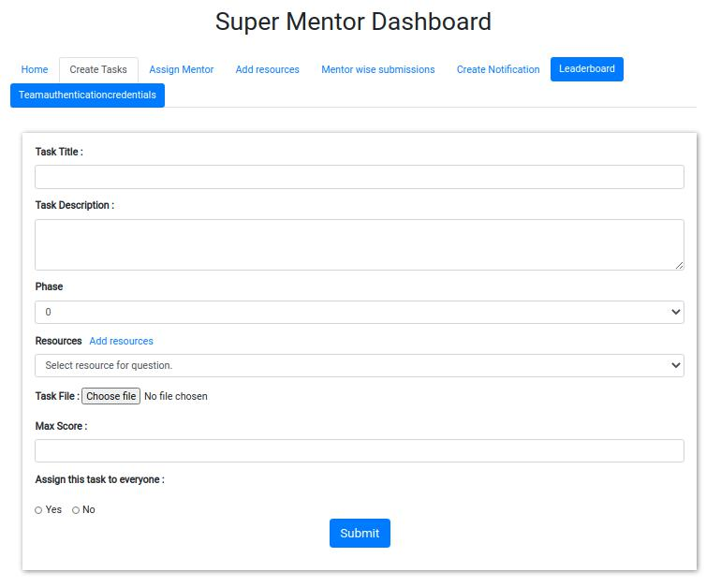

Only SUPERMENTOR has the accesibility to create tasks
While you are creating task and it has resorces ( Docs needed while working on this tasks ), then create Resource before

2. Creating resources
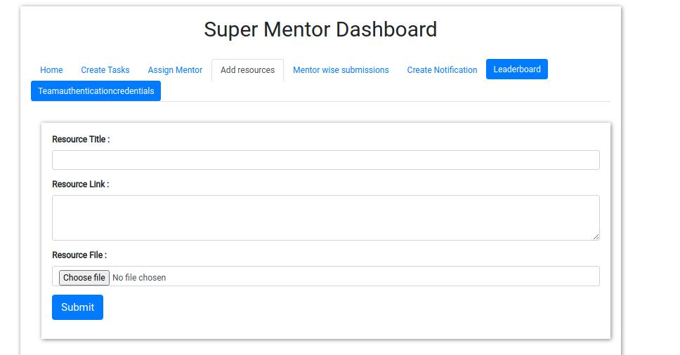

Only SUPERMENTOR has the accesibility to create resources

2. Assigning tasks to a team
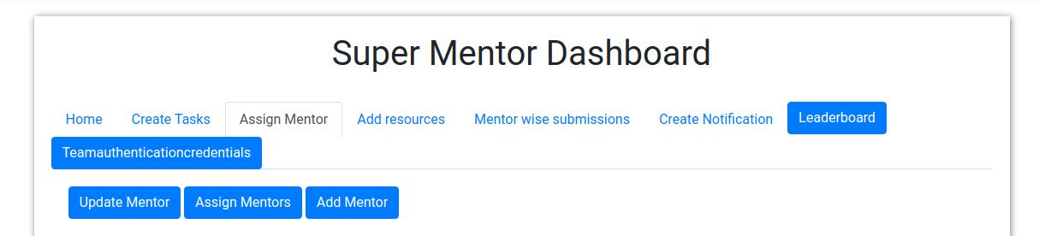

Go to 'Assign mentor tab'

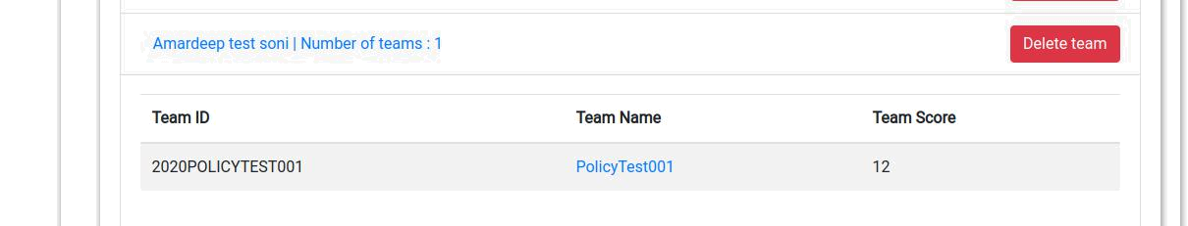

bottom you will see this tab (as shown in image)
click on the team to be assigned the task
once you click on the team it will redirect you to the new tab ( shown in the below image)
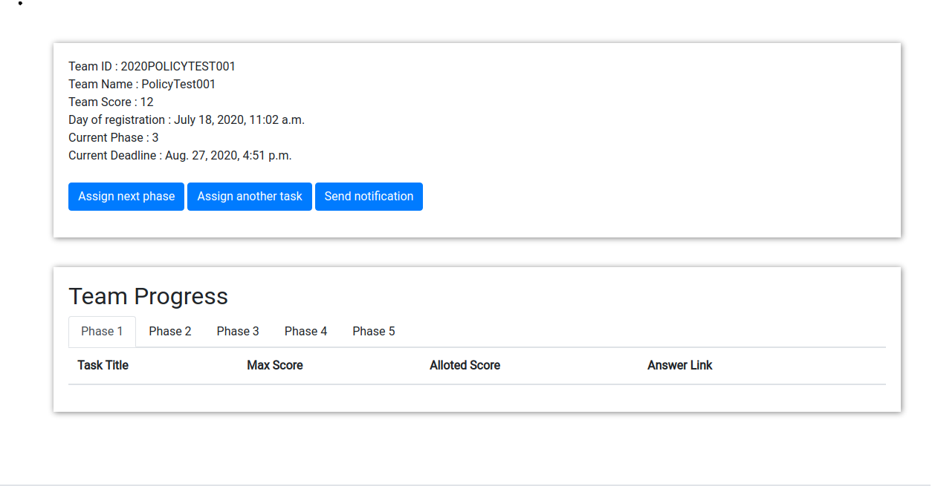

Assign next phase


when a Team is new by default it will be in phase-0 use this button to bring them to phase-1
when a Team completes the given phase task clicking this button would increment their phase

Assign another task


use this button to assign the task to the given team.
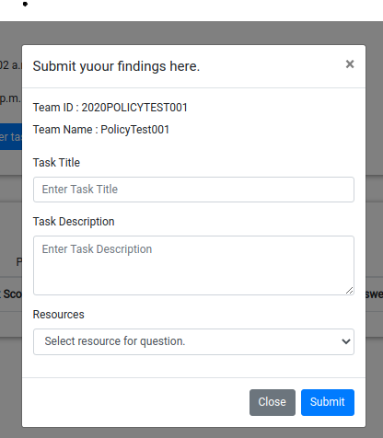

now fill the task title and task description and submit it to assign the task to the given team
NOTE: the title and description should match with the existing task created by supermentor

Send noticification


click on this button you will get a tab (shown in the image)

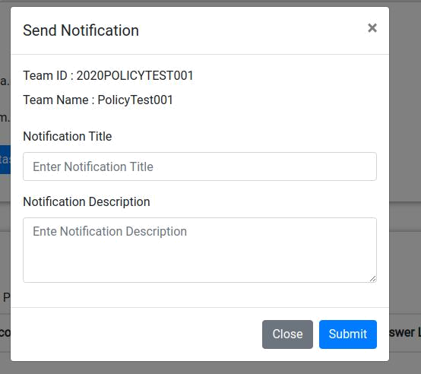

fill the form and submit it
once you submit it the message will be visible on the team dashboard

